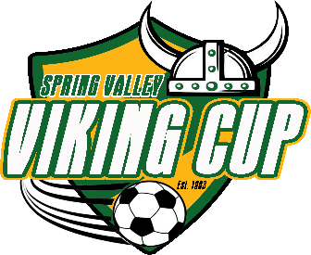

The 2022 Spring Valley Viking Cup

Foul Weather and Covid Protocols

Teams, Coaches, Parents, and Fans: Please find below information regarding how we will proceed in the event of foul weather conditions and the required Covid-19 protocols for this event.

Foul Weather
- Currently, weather projections look pretty good. There could be some rain here or there, but at this time (a week out) things look fine. Obviously, this could change. Therefore:
  - Sprinkles, light showers, and even brief heavier showers should have no impact on play.
  - Lightning or heavy rains that create dangerous, unplayable, or destructive conditions will cause delays. Should this happen, updates will be posted at www.thevikingcup.org, and tournament staff will contact coaches directly if needed.
  - The Viking Cup makes every effort possible to meet the 3-game guarantee even in the event of inclement weather. There are no open fields within the schedule, but half are lighted. Games can be pushed later into the evening if needed, and, should it become necessary, games can also be moved to Sunday. Historically, there has only been one year where we were unable to accommodate all bracket games despite many weather events over 30 years.
  - Coaches will receive outlook updates next week and, if warranted, plans to adjust.

Covid Protocols
- Currently (and fortunately), things in this realm continue to move in the right direction. As everyone knows, cases and restrictions are lessening. Still, some restrictions remain in place. Therefore:
  - Richland 2 has a mask rule in place, even at outdoor sporting events. This will have no impact on teams while playing (unless voluntary on the part of a player). For anyone without a mask, tournament gate staff will have available and provide disposable masks at each gate.
  - Most fields have ample bleacher space (SCUFC fields do not). Fans should bring chairs to SCUFC fields (C1 and C2, behind Spring Valley Presbyterian Church). Fans wishing to distance from others will be allowed to sit around the SCUFC fields with the exception of two locations. Fans will not sit on team sidelines within 10 yards (30 feet) of any team (teams sit between the two fields), and fans will not sit behind goals (defined as any area behind a goal and within the width of the 6-yard box).
  - Fans at field HP (Harry Parone Stadium) will sit in bleachers only (they are extremely spacious). Only the bleachers on the visitor side (same as the entry gate) will be in use.
  - Fans at fields SV1, SV2, and SV3 may also choose to sit around the fields if they wish to distance from others (bring portable chairs if you wish to do this). On these fields, teams will use one full sideline. Fans may sit on the opposite sideline and on ends of each field, but fans will not sit behind goals (defined as any area behind a goal and within the width of the 6-yard box).
  - Fans are expected to exhibit proper sportsmanlike conduct at all times. Should any tournament staff or referee determine that fans are creating a danger to players or an unsportsmanlike situation, those fans will be relocated.
  - Simply be considerate and respectful of others and exercise good judgment.

